**Introduction**

The Problem

Moving to a different state is difficult, especially with children. Many parents are hesitant to move because of the uncertainties of how it would disrupt their children’s current lifestyle. What if there was a way to make the transition easier? While it is never easy to say, “Good-bye,” to old friends and try to make new ones, what if there was an easy way to initiate your social life in a new location?

The Solution

I created a two tier computer program to assist families with gaining a general understanding of an area prior to moving. The first tier analyzes the county that they are thinking of moving to. The outputs reveal the top venues in the area broken down by borough. The second tier analyzes the major factors that make up the family’s lifestyle in proximity to where they think they might want to live. The outputs reveal what is available within a 10 mile (16 km) radius from their desired location. The purpose is to see if where they think they might want to live would have similar venues as their current location, presumably making their social integration easier.

Example

In my example (shown below), I chose to analyze Chester County, Pennsylvania as my first tier analysis. I then narrowed my analysis in the second tier to what a family might be looking for if they were to consider moving to Malvern, Pennsylvania, a location within Chester County.

**Data**

Wikipedia.com: The names of the boroughs within Chester County were found on Wikipedia.com. This is a list of locations that will be used to gain an understanding of what is available within the different parts of the county.

Google: The coordinates of the boroughs were found using Google’s search function and Google Maps. This list of coordinate data will be used to help search for venues and plot the data on a map.

Venues: The venue data was all found using the Foursquare API. This list of data is what is available to do in the area, based on a specific radius (in meters) defined by the user.

**Methodology: Tier 1 Analysis**

Exploratory Data Analysis

Chester County is located west of Philadelphia, within the eastern section of the state. It has # of boroughs scattered throughout the county.

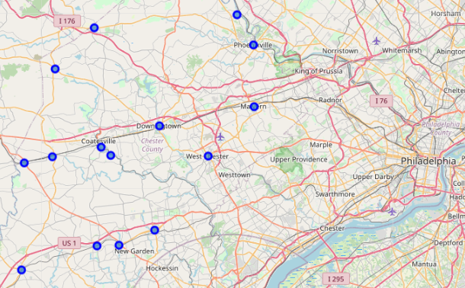

Based on the coordinates of the boroughs, using a search radius of 1600 meters per borough, there are 402 venues throughout the county within 121 unique venue categories.

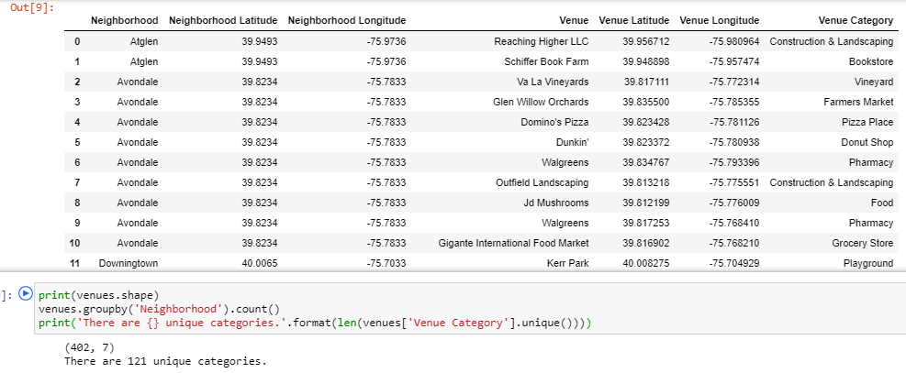

Machine Learning

K-means clustering is a machine learning algorithm that clusters a collection of data points based on certain similarities. The outcome is to locate the center, or centroid, of the data to help further understand the similarities and differences between the data point. K-means clustering was used to further analyze the data within Chester County.

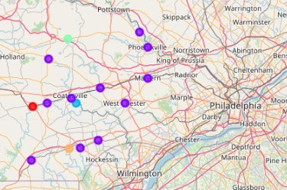

Below are the results per cluster:

Cluster Label 0:



Custer Label 1:

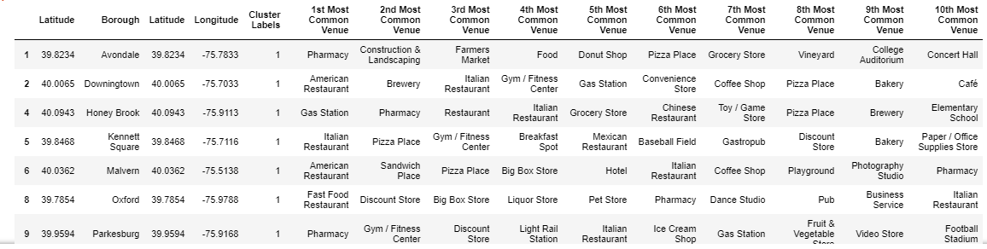

Cluster Label 2:



Cluster Label 3:



Cluster Label 4:



**Methodology: Tier 2 Analysis**

The search criteria is based on a hypothetical family who would like to replicate their lifestyle without having to drive more than 10 miles in any direction from where they live. I created 11 different venue categories and search for them using the foursquare API as Malvern, PA as my starting point. I then scrubbed the data and put all of the results into their own “master dataframe” for further analysis. I then grouped the venues by neighborhood to determine which area near Malvern, PA has the most venue categories that fit my hypothetical family’s lifestyle. Below are the examples of the data I gathered.

The eleven categories are: Church, Aldi, Golf Course, Library, Shopping Mall, Gas Station, School, Museum, Park, Zoo, and Thai Restaurants

A portion of the combined dataframe:

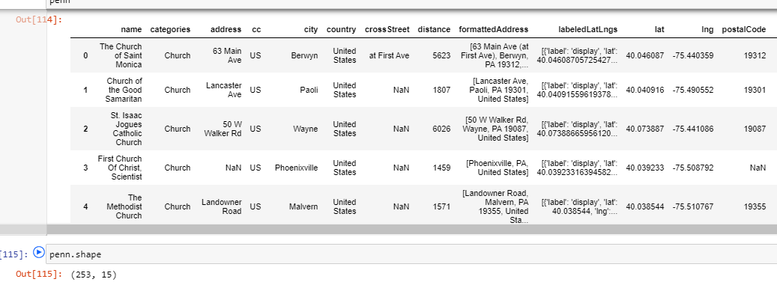

Map of the various venues:

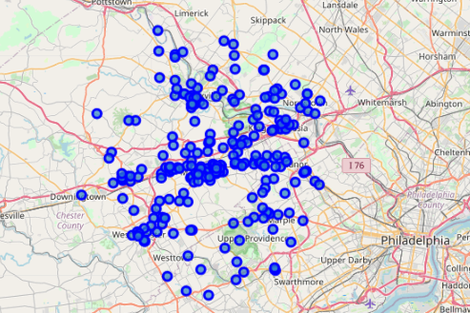

Summary description of the data:

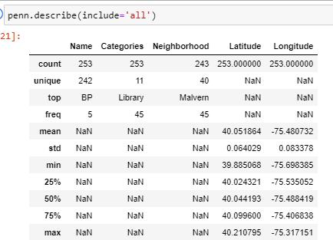

Analysis showing that the neighborhood of Berwyn has 10 matching venues across 6 of the 11 unique categories.

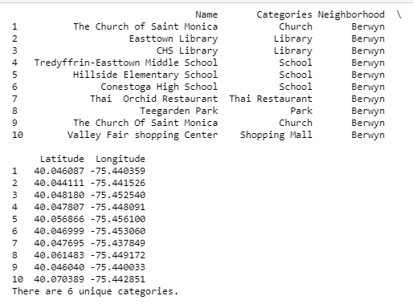

**Results**

Tier 1 analysis

The results of the Tier 1 analysis show the various venues of Chester County, Pennsylvania. Based on the analysis, there are a wide diversity of venues within the county, giving way to plenty of activities to acclimate a new family into the area. Further analysis provided by the k-means machine learning programming demonstrate that most of the boroughs within Chester County are similar. This explains that our family has a wide selection within the county to choose where to live.

Tier 2 analysis

Based on our hypothetical search, Malvern returned with the highest results of 10 unique categories out of 11 that are located within a 10 mile radius. Three other neighborhoods returned 8 unique categories out of 11 within a 10 mile radius. They are Norristown, Phoenixville, and Westchester. Interestingly enough, the one category that was missing from Malvern, PA was the zoo, which was present within the Norristown search. Part of the Malvern data is shown below.

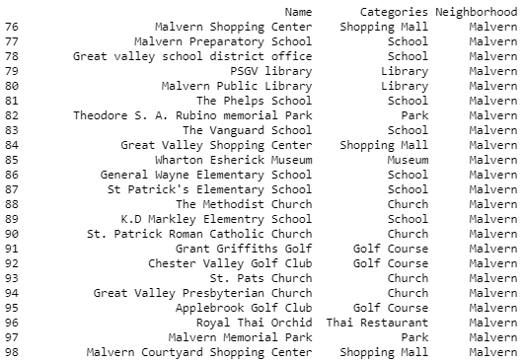



**Discussion**

Based on my hypothetical scenario, the family looking to relocate to Chester County, PA would seem to fit in well in Malvern, which provided for 10 of their 11 unique venue categories. The lone category missing within a 10 miles radius of Malvern, PA was the zoo. Norristown, a nearby neighborhood to Malvern, which was tied for the second best fit, had a zoo within its 10 mile radius. I did a quick Google search of the distance between Malvern and zoo within Norristown and discovered that they are only 14 miles apart. If my hypothetical family were to move to the north east section of Malvern, they might have the zoo within their desired 10 mile radius and thus having all 11 of their preferred venues. This reinforces the possibility of Malvern, PA being the best fit for my hypothetical family to move, based on their current social preferences. The Norristown data is shown below.

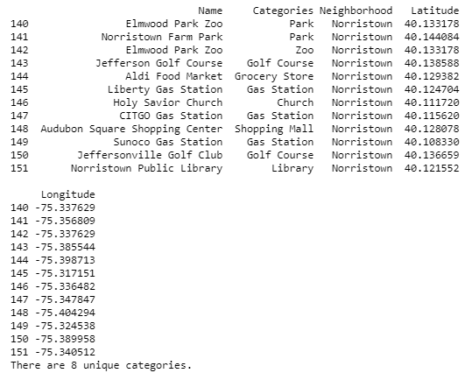

**Conclusion**

It’s not easy relocating a family to a new state. As a result, many people choose to stay where they are. I created a computer program that helps display and analyze various boroughs within a county and the venues located within. I was then able to analyze a particular borough to see if it would be a good fit for the family, based on their 11 venue category preferences. The end results showed that it would be possible for the new family to have a similar lifestyle in Malvern, Chester County, Pennsylvania without much driving.